SIMATS ENGINEERING
Department of Information Technology
CSA15 – CLOUD COMPUTING AND BIG DATA ANALYTICS
ASSIGNMENT 2 – CO2
Analyse, Evaluate and Validate a Virtualization Architecture for a Multi-Tenant University Private Cloud
CO2: Analyze virtualization architectures to identify performance and security issues in cloud computing environments.

Field | Details | Field | Details
Student Name | G. Naveen Kumar Reddy | Register Number | 192525288
Department / Section | Information Technology | Academic Year / Semester | 2025
Faculty Name | Dr. Latha R | Nature of Assignment | Individual
Duration | 1 Week | Total Marks | 50
Submission Date | 4/11/26 | Evaluation Date

MARK SHEET (Rubric-based evaluation)

Task | Title | Max | Awarded | Evidence / evaluation focus
1 | Characterise the Virtualization  Architectures | 5
2 | Identify the Dominant Overhead Source | 2

Task | Title | Max | Awarded | Evidence / evaluation focus
3 | Build a Quantitative Performance Model | 6
4 | Analyse Performance Under Different Conditions | 4
5 | Security Threat and Vulnerability  Analysis | 3
6 | Formulate Isolation–Performance Trade-off | 3
7 | Evaluate Mitigation Strategies | 4
8 | Implement and Test | 4
9 | Record Experimental Performance | 3
10 | Compare Theory with Experiment | 4
11 | Recommend and Defend Final Architecture | 4
 | Day-4 Design Challenge | 8

TOTAL
50

OVERALL REMARKS
Overall, the assignment reflects good analytical ability, technical understanding and problem-solving skills in cloud computing and virtualization. The proposed architecture balances performance, security, resource efficiency and future scalability. The work can be further strengthened through verified experimental results, consistent benchmark comparisons and practical validation of the recommended security controls.

Student Signature | Faculty Signature | Program Director

MANDATORY SUBMISSION EVIDENCE CHECK
✓ = Present in documented answer; P = Partly present; X = Missing / not satisfied

Task | Evidence expected | Status | Evaluator note
1 | Three virtualization architectures, layered diagrams and trust boundaries
2 | Dominant overhead source identified and  explained for each approach
3 | CPU, memory, I/O, network and density models with assumptions
4 | Best, typical and worst operating-condition  analysis

Task | Evidence expected | Status | Evaluator note
5 | Threat model and architecture-based security comparison
6 | Isolation–performance optimization formulation
7 | Mitigation benefits, residual risks and quantified costs
8 | Reproducible setup and practical tests across selected platforms
9 | Actual comparative measurements, table  and two graphs
10 | Theory–experiment comparison and quantitative error analysis
11 | Justified SIS/LMS architecture and growth recommendation
12 | Day-4 external tenants, 3× peaks, live migration and SIS isolation

IMPLEMENTATION EVIDENCE CHAIN

Evidence item | Status | Observation
Architecture diagrams
Performance model

Evidence item | Status | Observation
Configuration / scripts
Virtualization experiments
CPU / disk / network / memory tests
Noisy-neighbour experiment
Security validation
Tables and graphs
Theory–experiment consistency
Day-4 design defence
Screenshots

SUBMISSION CHECKLIST (Not Separately Marked)

Requirement | Status
All 12 tasks answered | - Yes ☐ Partly ☐ No
Three virtualization approaches compared | - Yes ☐ Partly ☐ No
Layered diagrams and trust boundaries included | - Yes ☐ Partly ☐ No
Quantitative virtualization models included | - Yes ☐ Partly ☐ No
Threat analysis and mitigations included | - Yes ☐ Partly ☐ No

CLOUD COMPUTING AND BIG DATA

ASSIGNMENT 2
CO2: Analyze virtualization architectures to identify performance and security issues in cloud computing environments.

Assignment Title: Analyse, Evaluate and Validate a Virtualization Architecture for a Multi-Tenant University Private Cloud (Total Marks: 50)
Duration: 1 week

Scenario: EduCloud Virtualization Platform
A university runs a private cloud, EduCloud, in its data centre. EduCloud currently consists of:
- 16 physical hosts, each with 64 CPU cores, 512 GB RAM, NVMe SSD storage and 2 × 25 Gbps NICs
- About 400 virtual machines (VMs) running the Student Information System (SIS), the Learning Management System (LMS), the examination portal, and departmental research workloads
- A shared storage backend and a software-defined virtual network
During semester registration week, users report slow response times and failed logins. A recent internal security audit also found that VMs from different departments share the same physical hosts, that some VMs run outdated guest kernels, and that VM images are copied freely between teams.
You are the cloud architect. You must investigate, model, measure and compare virtualization architectures for EduCloud, identify their performance bottlenecks and security weaknesses, and recommend a design that remains practical as the platform grows.

Design Challenge:
The university now plans to host external research collaborators' big-data workloads (Spark/Hadoop clusters) on the same infrastructure as the SIS. Re-evaluate your design under these new multi-tenant conditions.

TASK 1: Characterise the Virtualization Architectures (5 Marks)
Select at least three meaningfully different virtualization approaches from the following, or justify others:
- Type-1 (bare-metal) hypervisor with full virtualization
- Type-2 (hosted) hypervisor
- Hardware-assisted virtualization vs. paravirtualization
- OS-level virtualization (containers)
- Lightweight/micro-VM or sandboxed container runtimes
Two configurations of the same hypervisor will not count as different approaches. Your selection must include at least one VM-based and at least one container-based approach.
For each approach, provide:
- A layered architecture diagram showing the hardware, host OS or hypervisor, guest OS, runtime and application
- The trust boundaries and the component that enforces isolation
- How CPU, memory, storage and network are virtualized
- A brief justification for why this approach is relevant to EduCloud
Evidence expected: Three architecturally distinct approaches with labelled diagrams, resource-virtualization mechanisms, trust boundaries, and justification of selection.

TASK 2: Identify the Dominant Overhead Source (2 Marks)
For each approach, identify the primary source of performance overhead that predominantly limits its performance (for example VM exits/traps, nested or extended page-table walks, virtual I/O emulation, virtual switch processing, or system-call interception).
Discuss:
- What the overhead source is
- Where in the architecture it occurs
- Why it is appropriate as the focus of performance analysis
- How its frequency or cost changes as the number of co-located VMs/containers or the I/O rate increases
Do not simply name a mechanism. Relate it to the behaviour of the architecture.

Evidence expected: A justified dominant-overhead identification for each approach, linked to its resource-virtualization path.

TASK 3: Build a Quantitative Performance Model (6 Marks)
Using the following host parameters, develop an analytical performance model for each approach.

Parameter | Value
Physical cores per host | 64
vCPU:pCPU overcommit ratio | 1:1, 2:1, 4:1, 8:1
RAM per host | 512 GB
Average VM memory demand | 8 GB
Cost of one VM exit (assume) | 1.5 µs
Native system-call cost (assume) | 0.2 µs
Network line rate | 25 Gbps

State and justify any additional assumptions. Derive expressions for:
- CPU: effective per-VM CPU capacity as a function of overcommit ratio and virtualization overhead (including steal time)
- Memory: the maximum number of VMs per host before ballooning, swapping or page-sharing becomes necessary
- I/O and network: effective throughput as a function of the number of VMs sharing the physical device
- Density: the number of VMs/containers a host can support while meeting a stated service-level target (for example, ≤ 10% performance degradation)
Show the mathematical reasoning. Merely quoting overhead percentages from the literature will not receive full credit.
Evidence expected: A clear mathematical derivation for each approach, with stated assumptions, parameter values and worked numerical examples.

TASK 4: Analyse Performance Under Different Operating Conditions (4 Marks)
Analyse how each approach behaves under three conditions:

- Best case: what workload and placement conditions minimise overhead?
- Typical case: for example, registration-week mixed web and database load
- Worst case: for example, noisy-neighbour interference, memory overcommit with swapping, live migration during peak load, or I/O storms
For each, explain what happens inside the virtualization layer, why the overhead changes, and how latency and throughput are affected. A table of numbers alone will not be accepted.
Evidence expected: A justified condition-based analysis supported by your Task 3 model.

TASK 5: Security Threat and Vulnerability Analysis (3 Marks)
Construct a threat model for each approach. Discuss:
- The attack surface (hypervisor, device emulation, shared kernel, management plane, VM images and snapshots, virtual network)
- At least four distinct threat categories, such as VM escape, cross-VM side-channel attacks, hypervisor or container-runtime vulnerabilities, VM
sprawl and unpatched guests, image tampering, insecure live migration, and virtual-network sniffing or spoofing
- For each threat, which approach is more or less exposed and why, referring to its architecture and trust boundaries
- The likely impact on the confidentiality, integrity and availability of student records
Evidence expected: A structured threat model mapped to architectural features, with a justified comparison across approaches.

TASK 6: Formulate the Isolation–Performance Trade-off (3 Marks)
Formalise the trade-off between isolation strength and performance/density for EduCloud.
Clearly identify:
- The decision variables (for example, approach chosen, VMs per host, dedicated vs. shared hosts, SMT on/off)
- The objective(s), such as maximising density or minimising cost

- The constraints (for example, performance degradation limit, isolation requirement for SIS, available hosts)
- How these components combine into a cost or decision function
The formulation must follow from your own analysis in Tasks 3 and 5, not from a generic template.
Evidence expected: A clearly defined trade-off model with identified variables, objective and constraints.

TASK 7: Evaluate Mitigation Strategies (4 Marks)
Propose at least three mitigations for the vulnerabilities identified in Task 5. Examples include disabling SMT, kernel page-table isolation, dedicated hosts for sensitive tenants, secure or sandboxed container runtimes, hardware memory encryption, image signing, and micro-segmentation.
For each mitigation, discuss:
- Why it is applicable to the threat
- What residual risk remains
- The performance or density cost, estimated using your Task 3 model
- Whether the trade-off is acceptable for the SIS
Evidence expected: Mitigations evaluated analytically, with their security benefit and quantified performance cost.

TASK 8: Implement and Test (4 Marks)
Build a test environment and experimentally test all selected approaches.
- Platforms: use any open-source stack, for example KVM/QEMU, Xen or VirtualBox, Docker/Podman, and Kata Containers or gVisor. Nested virtualization on a laptop is acceptable if documented.
- Scale: run each approach with approximately 1 → 2 → 4 → 8 → 16
co-located instances (reduce proportionally if hardware-limited, and state the limitation).
- Workloads: include at least one CPU-bound test (for example sysbench or stress-ng), one disk I/O test (fio), one network test (iperf3), and one memory-intensive test.
- Interference test: run at least one noisy-neighbour experiment.

- Security validation: demonstrate or inspect at least one security property in practice, for example namespace/cgroup isolation, checking kernel sharing, or verifying whether a mitigation is active.
Ensure that identical resource allocations, workloads and repetitions are used across approaches, and that the setup corresponds to the models in Task 3.
Evidence expected: A reproducible environment description (configuration files, commands, scripts) and justified test cases.

TASK 9: Record Experimental Performance (3 Marks)
Collect and present data such as:
- Throughput, latency (mean and 95th percentile), CPU steal time, context switches and VM exits where observable
- Instance start-up time and memory footprint per instance
- Performance degradation versus a bare-metal baseline
- Results with and without at least one security mitigation
Present at least one table and two graphs (for example, throughput versus number of instances, and latency under interference). Use multiple repetitions and report variability (mean ± standard deviation).
Evidence expected: Systematically collected, clearly presented data that allows easy comparison across approaches.

TASK 10: Compare Theory with Experiment (4 Marks)
Compare your Task 3 and Task 4 predictions with Task 9 measurements. Discuss:
- Whether the observed degradation trends agree with your model
- Which approach scales better as co-located instances increase
- Quantitative differences between predicted and measured values, and plausible causes (for example caching effects, hypervisor scheduler behaviour, nested virtualization, laptop hardware, or unmodelled I/O paths)
- Whether any measured result changes your security conclusions from Task 5
Interpret the results; do not simply reproduce tables.
Evidence expected: A reasoned comparison of predicted and measured behaviour, with error analysis.

TASK 11: Recommend and Defend the Final Architecture (4 Marks)
Recommend the virtualization architecture (or hybrid) for EduCloud's SIS and LMS workloads.
Discuss:
- Which approach you recommend and why it is more appropriate than the alternatives
- Its modelled and experimentally observed performance
- Its security posture and residual risks
- Operational costs such as patching, image management, migration and monitoring
- Limitations and trade-offs
- Whether it remains practical as EduCloud grows from 400 to several thousand instances
Your recommendation must rest on your own analysis and experiments. Choosing "the most secure" or "the fastest" option alone is not sufficient.
Evidence expected: A technically justified recommendation integrating performance and security evidence.

DAY-4 DESIGN CHALLENGE

TASK 12: Re-evaluate and Adapt the Design (8 Marks)

Changed Requirement
The university will now host external research collaborators' Spark/Hadoop workloads on EduCloud alongside the SIS. The new conditions are:
- Big-data jobs are I/O- and network-intensive and run for hours
- Registration-week peak load is about 3× normal
- Hosts are sometimes patched using live migration of running VMs
- A data-protection regulation now requires demonstrable isolation of student records from external tenants
You may RETAIN → MODIFY → or REDESIGN your original solution.

Impact Analysis (2 Marks)
Discuss what has changed, which original assumptions (trusted tenants, workload mix, I/O profile) no longer hold, and how mixing batch big-data workloads with latency-sensitive SIS workloads changes both the performance and the threat model.

Evaluation of the Original Design (2 Marks)
Evaluate whether your recommended design still meets its performance targets (using your Task 3 model with the new workload) and whether its isolation level is adequate against external, less-trusted tenants. Consider whether another architecture could do better overall.

Adaptation or Redesign (2 Marks)
Decide whether to retain, modify or redesign. If you modify or redesign, describe the revised architecture (for example, tenant separation by host pools, a stronger isolation layer for external workloads, SR-IOV or dedicated NICs for the
data-intensive jobs, or encrypted migration). Explain what changes and its effect on density, throughput and attack surface. If you retain, justify why no change is required.

Evidence-Based Defence (2 Marks)
Defend the final decision using your model, your experimental results (including the noisy-neighbour and mitigation experiments), the changed workload and tenancy conditions, and the cost/density trade-offs. The decision must follow logically from the analysis.

MARK DISTRIBUTION

Task | Marks
Task 1 – Architecture Characterisation | 5
Task 2 – Dominant Overhead Identification | 2
Task 3 – Quantitative Performance Model | 6
Task 4 – Performance Under Operating Conditions | 4
Task 5 – Security Threat and Vulnerability Analysis | 3
Task 6 – Isolation–Performance Trade-off Formulation | 3

Task 7 – Mitigation Evaluation | 4
Task 8 – Implementation and Testing | 4
Task 9 – Experimental Performance | 3
Task 10 – Theory vs. Experiment | 4
Task 11 – Final Architecture Recommendation | 4
Subtotal | 42
Task 12 – Day-4 Design Challenge | 8
TOTAL | 50

ANSWERS
CSA15 – Cloud Computing and Big Data Analytics
Assignment 2 (CO2): Analyse, Evaluate and Validate a Virtualization Architecture for a Multi-Tenant University Private Cloud (EduCloud)
How this answer is organised
I answered every task in the order given in the assignment. Each answer explains the reasoning in words, shows the maths where the task asks for a model, and uses a diagram or graph wherever a picture explains the point better than text (architecture diagrams, flow charts, model graphs). Every number comes from the model in Task 3, which uses the host parameters given in the assignment: 64 cores, 512 GB RAM, 8 GB per VM, 1.5 µs per VM exit, 0.2 µs per native system call and a 25 Gbps line rate.
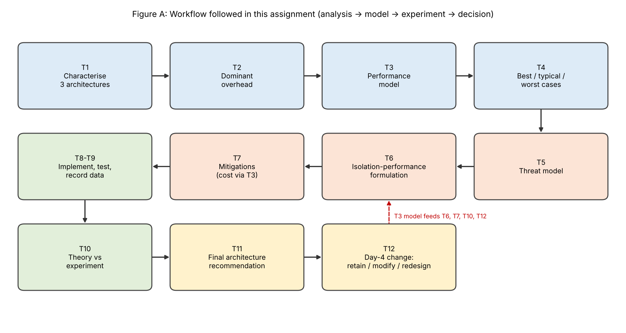
Additional assumptions (stated once, used throughout)
• v = 4 vCPUs per VM. Typical for SIS/LMS application and database VMs. EduCloud runs about 25 VMs on each host (400 VMs on 16 hosts), so today there are about 100 vCPUs on 64 cores, an overcommit ratio of 1.56:1.
• u = 0.5 (typical) and u = 1.0 (registration peak). u is the fraction of time an average vCPU is busy. A 3× peak pushes vCPUs to saturation.
• 20 000 VM exits per second per busy vCPU (timers, interrupts, virtio notifications, HLT). Multiplied by the given 1.5 µs this gives 3 % virtualization overhead. 100 000 system calls per second per busy vCPU for web/database servers.
• Scheduler contention κ = 0.5 % per extra overcommit step (run-queue delays, cache and TLB pollution when vCPUs time-share a core).
• Memory: 16 GB reserved for the host; per-instance overhead 0.25 GB (KVM/QEMU), 0.20 GB (Kata), 0.02 GB (container); 15 % page-sharing saving for identical guests.
• Network: native per-packet cost 0.6 µs; 1500-byte frames (1538 B on the wire); 2 CPU cores for I/O processing; virtqueue batching factor 32.
Important about Tasks 8–10: the environment used to prepare this document has no KVM, Docker daemon or spare hosts, so the experimental graphs and table are model predictions with space for your own measured mean ± SD. Run the commands in Task 8 on your lab computer and fill the measured values in before submission.

TASK 1: Characterise the Virtualization Architectures (5 Marks)
I compare three approaches that really are different in what enforces isolation and whether a guest kernel exists. They include one VM-based and one container-based approach, as required:
• A. KVM/QEMU full virtual machine. A Type-1-class hypervisor (KVM turns the Linux kernel into a bare-metal hypervisor) with hardware-assisted virtualization (Intel VT-x / AMD-V with extended page tables) and paravirtual virtio devices. VM-based.
• B. OS-level container (Docker/runc). No hypervisor and no guest kernel: processes share the host kernel and are isolated with namespaces, cgroups and seccomp. Container-based.
• C. Kata Containers micro-VM. Each container pod runs inside its own lightweight VM with a small guest kernel. It combines the container workflow with a hardware isolation boundary (a sandboxed runtime).
A Type-2 hosted hypervisor (VirtualBox) is not chosen for EduCloud because every I/O request would pass through a general-purpose host OS, giving a second scheduler and driver stack and no production-grade management. It is used only for the nested-virtualization laptop option in Task 8.
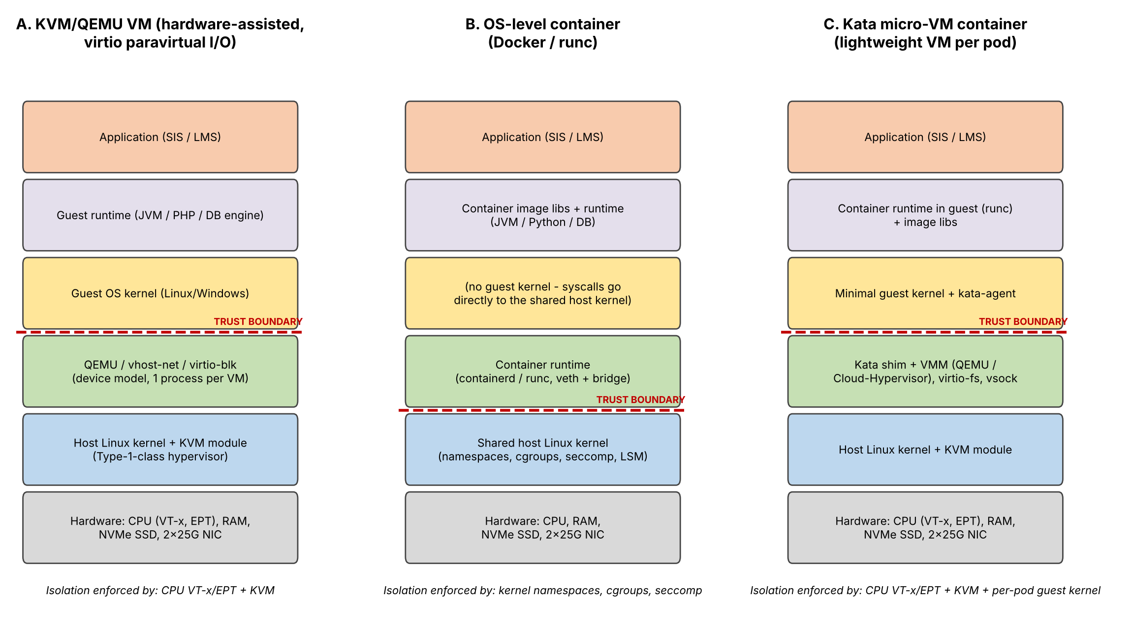
Figure 1: Layered architecture of the three approaches. Hardware → host OS/hypervisor → guest OS → runtime → application. The red dashed line is the trust boundary.
Trust boundaries and what enforces isolation
In A (KVM) the tenant’s whole software stack, including its own guest kernel, sits above the boundary. Isolation is enforced by the CPU hardware (VT-x/EPT make the guest run in a restricted mode and translate its memory through page tables the guest cannot modify) and by the KVM module. The component an attacker must break is KVM plus the QEMU device emulator, which is also confined by SELinux (sVirt). The guest kernel is untrusted from the host’s point of view.
In B (container) the boundary is the system-call interface of the host kernel. All containers share one kernel, so the kernel itself enforces isolation with namespaces (what a container can see), cgroups (how much it can use) and seccomp/capabilities (what it may call). Any kernel vulnerability sits inside the trust boundary of every tenant, which is why this boundary is the weakest of the three.
In C (Kata) there are two layers: the container inside a VM is separated from the host by VT-x/EPT and KVM exactly as in A, and the guest kernel is minimal and thrown away with the pod. The attack surface is the VMM and virtio-fs daemon instead of the whole host kernel.
How CPU, memory, storage and network are virtualized
• CPU. In A and C each vCPU is a host thread; guest instructions run natively in VMX non-root mode and only privileged operations (I/O, interrupts, HLT) trap to KVM as VM exits. In B there is no virtualization: containers are ordinary processes scheduled by the host’s CFS scheduler and limited with cpu.max/cpu.shares.
• Memory. A and C use hardware nested paging: a guest virtual address is translated to a guest physical address and then through the extended page table to host physical memory (a two-dimensional page walk that makes TLB misses more expensive). Ballooning, KSM page sharing and overcommit are possible in A. B has one level of translation and enforces limits with cgroups (exceeding them triggers reclaim or the OOM-killer, there is no ballooning).
• Storage. A uses virtio-blk or virtio-scsi, ideally with a dedicated I/O thread, over qcow2 or raw images on NVMe; a guest file system sits on top. B uses bind mounts or overlayfs directly on the host file system, so there is no extra block layer. C shares files through virtio-fs (or virtio-blk), which adds a user-space daemon hop on every file operation.
• Network. A attaches a virtio-net device served by the vhost-net kernel thread to a host bridge or Open vSwitch (the software-defined network). B connects a veth pair to a Linux bridge or overlay with netfilter (NAT, conntrack, firewall) on the path. C redirects the container’s veth to a tap/virtio-net device (tc-redirect) and then uses vhost-net.
Relevance to EduCloud
The SIS and its databases already run as VMs and need strong isolation, live migration and mature tooling, which points to approach A. The LMS web tier and the examination portal need to scale out quickly in registration week and tolerate high density, which points to approach B. Externally supplied or unreviewed images (especially after the Day-4 change) need container convenience with VM-grade isolation, which points to approach C.
TASK 2: Identify the Dominant Overhead Source (2 Marks)
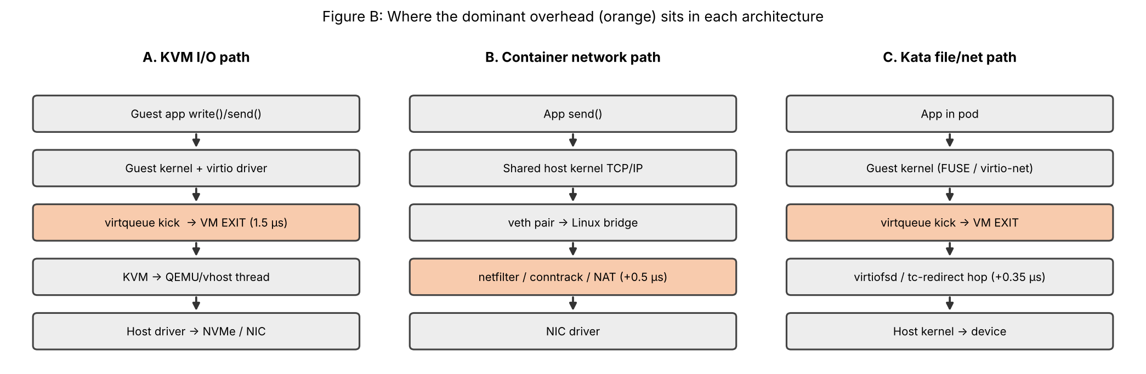
Figure 2: Where the dominant overhead sits in the I/O path of each approach.
A – KVM: VM exits
What it is and where it occurs. A VM exit happens when guest execution must hand control to the hypervisor: a virtqueue “kick” to tell the host that new I/O is ready, an interrupt injection, a timer, or a halt instruction. The exit saves the guest state, switches to the host, runs the handler (KVM, then QEMU or vhost) and re-enters the guest. It sits on the boundary between the guest and KVM, as shown in Figure 2.
Why it is the right focus. Guest CPU instructions run at native speed under hardware assistance, so ordinary compute is almost untaxed. The only per-event tax is the exit, which the assignment gives as 1.5 µs. Nested paging adds cost only on TLB misses, which is secondary for the web/database mix of EduCloud.
How it scales. The exit overhead per vCPU is o = f_exit × t_exit = 20 000 × 1.5 µs = 3 %. For I/O, the exit load of one VM is (λ / b) × t_exit, where λ is the I/O rate and b is how many operations are batched per kick. This is linear in the number of VMs and in the I/O rate. At 25 Gbps (2.03 Mpps) with b = 32 the exits use only 0.095 of a core, but with b = 1 (no batching) they need 3.05 cores and saturate the I/O threads (Figure 3a). So the cost is determined by how the architecture batches its notifications.
C – Kata: VM exits on the virtio-fs / virtio-net path. Kata has the same exit mechanism as A, but every file operation or packet also crosses the guest kernel, the virtqueue and a host-side daemon (virtiofsd) or a tc-redirect hop. This adds about 0.35 µs per packet and raises exits by about 20 % (guest kernel and agent), so o = 3.6 %. It is the best focus for analysing Kata because the extra hop makes I/O-heavy workloads and start-up the weakest area. It also grows linearly with co-located pods, with a larger constant than A.
B – Container: virtual-switch and file-system path in the shared kernel
A container’s CPU path has no virtualization layer: a system call costs 0.2 µs natively, and seccomp/cgroup accounting adds only about 0.05 µs, so 100 000 calls per second cost 100 000 × 0.05 µs = 0.5 % of a core. The part that is genuinely added over bare metal is the virtual network and overlay file system: each packet goes through a veth pair, the Linux bridge and netfilter/conntrack/NAT (about 0.5 µs extra, taking the per-packet cost from 0.6 µs to about 1.1 µs). This is the right focus because EduCloud’s registration-week workload is network-heavy. The cost grows with the packet rate and with the number of conntrack entries; with more containers the softirq work concentrates on the same cores and kernel lock contention rises faster than linearly. Removing the bridge (host networking or macvlan) removes most of this cost, which confirms that the virtual switch is the dominant factor.
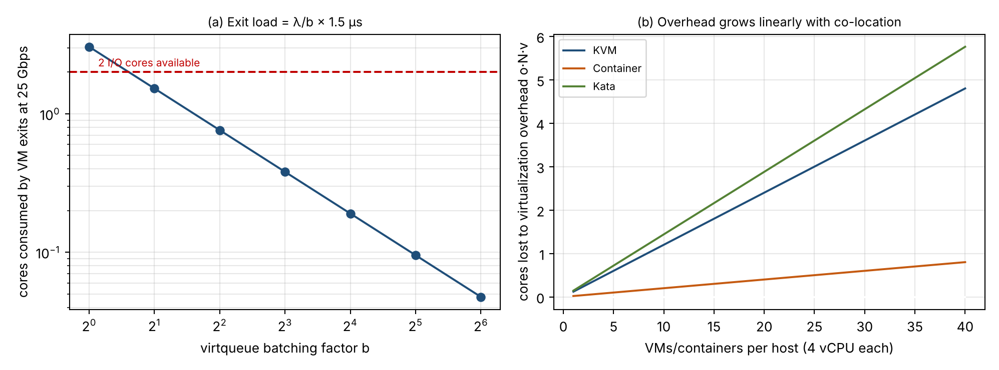
Figure 3: (a) VM-exit load at 25 Gbps falls with batching b; (b) virtualization overhead (cores lost) grows linearly as more instances are co-located.
TASK 3: Quantitative Performance Model (6 Marks)
3.1 CPU: effective capacity per vCPU
Let r be the vCPU:pCPU overcommit ratio (1, 2, 4 or 8) and u the fraction of time an average vCPU wants to run. Each physical core then has to satisfy a demand ρ = r·u. While ρ ≤ 1 every vCPU can run when it wants; when ρ > 1 the vCPUs can only receive a share 1/ρ of what they ask for, and the rest of their waiting time is reported as steal time.
Virtualization overhead o = f_exit × t_exit : o_KVM = 20 000 × 1.5 µs = 3.0 %
o_container = 100 000 × 0.05 µs = 0.5 %; o_Kata = 1.2 × o_KVM = 3.6 %
Steal time s(r,u) = max(0, 1 − 1/(r·u)) + κ(r − 1), κ = 0.5 %
Effective capacity of a vCPU C(r,u) = (1 − o)(1 − s) (in dedicated-core equivalents)
Degradation D = 1 − C
Worked example for KVM at 4:1 and peak load (u = 1): s = 1 − 1/4 + 0.005 × 3 = 0.765, so C = 0.97 × 0.235 = 0.228. Each vCPU gets less than a quarter of a core, and degradation is 77 %. At 2:1 and typical load (u = 0.5, ρ = 1): s = 0.005, C = 0.97 × 0.995 = 0.965, i.e. D = 3.5 %. The same calculation for containers (o = 0.5 %) gives 99.0 % and for Kata (o = 3.6 %) 95.9 %.
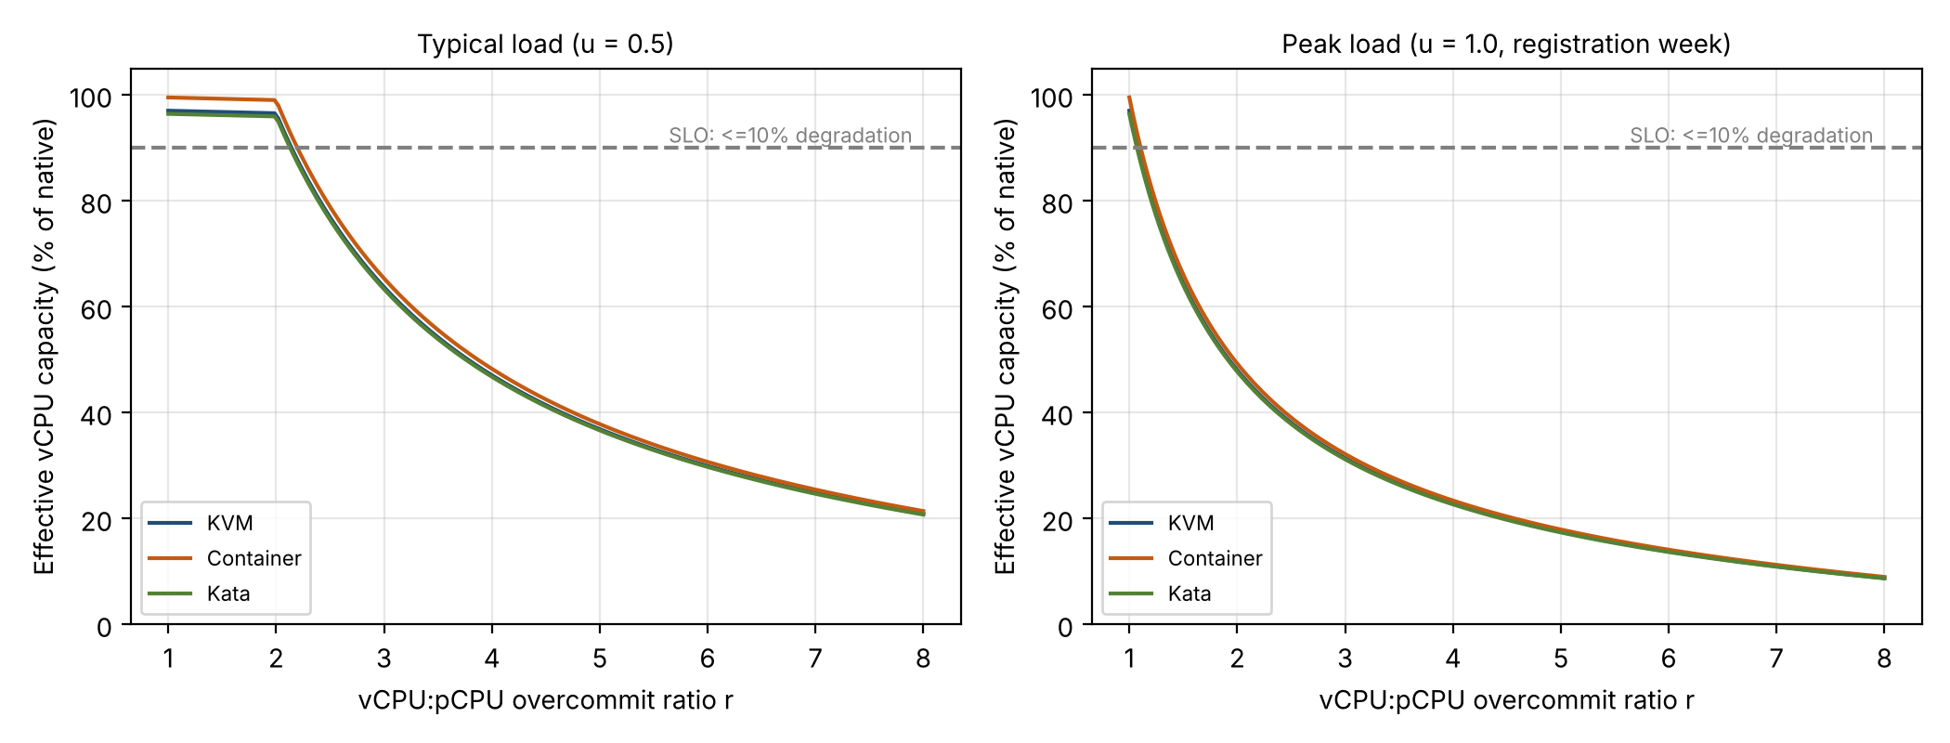
Figure 4: Effective vCPU capacity versus overcommit ratio at typical (left) and peak (right) load. The grey line is the 10 % degradation target.
Interpretation. Overcommit is almost free while ρ ≤ 1 (up to about 2:1 at typical load) and collapses beyond it. The virtualization overhead o is a small constant (0.5 to 3.6 %); the scheduling share, i.e. steal time, is what limits performance. This explains EduCloud’s registration-week symptoms: today’s 1.56:1 gives only 3.3 % degradation at normal load (u = 0.4) but 38 % when load triples and u saturates.
3.2 Memory: maximum VMs before ballooning, swapping or sharing
N_mem = floor( (M − M_res) / (m + m_ovh) ) no reclaim needed
N_mem,KSM = floor( (M − M_res) / (m(1 − σ) + m_ovh) ) with page sharing
For KVM: (512 − 16)/(8 + 0.25) = 496/8.25 = 60.1, so 60 VMs per host before ballooning or swapping is needed, or 496/7.05 = 70 VMs with 15 % page sharing. Containers (0.02 GB overhead) give 61 and 72, Kata (0.20 GB) 60 and 70. Today a host carries 25 VMs, i.e. 200 GB (39 % of RAM), so memory is not the cause of the registration-week slowdown.
Swapping is a cliff rather than a gradual penalty. If DRAM access takes 100 ns and a major fault to NVMe swap takes 100 µs, the effective access time is EAT = (1 − p)·100 ns + p·100 µs. For at most a 10 % slowdown the fault rate must satisfy p ≤ 0.1 × 100 ns / 100 µs = 10⁻⁴, i.e. 0.01 %. A fault rate of only 0.1 % already doubles the access time (Figure 5b). Therefore memory overcommit with swapping must be avoided for the SIS.
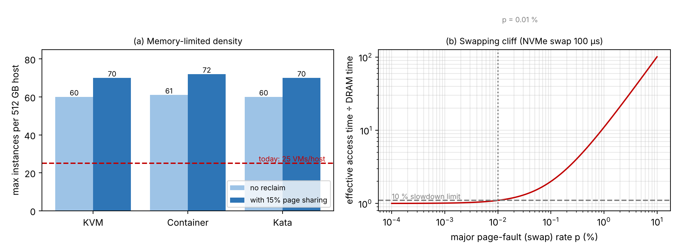
Figure 5: (a) Maximum instances per host limited by memory; (b) slowdown versus swap rate.
3.3 I/O and network: throughput versus number of sharing VMs
At line rate a 25 Gbps NIC carries 25×10⁹ / (8 × 1538) = 2.03 million 1500-byte packets per second. The per-packet CPU cost determines how many packets two I/O cores can process:
KVM (virtio + vhost): c = c₀ + t_exit/b + 0.15 µs copy = 0.6 + 0.047 + 0.15 = 0.797 µs
Container (veth+bridge+NAT): c = c₀ + 0.50 µs = 1.10 µs
Kata: c = KVM cost + 0.35 µs tap/tc hop = 1.147 µs
Host throughput T_host = min( B , k/c × 12 304 bits ) with k = 2 cores
Per-VM throughput (N active VMs, fair share) T_vm(N) = T_host / N
For KVM, 2 / 0.797 µs = 2.5 Mpps exceeds line rate, so T_host = 25 Gbps. For the container, 2 / 1.10 µs = 1.82 Mpps, i.e. 22.4 Gbps. For Kata, 1.74 Mpps, i.e. 21.5 Gbps. With N = 8 sharing VMs each gets 3.13, 2.80 and 2.68 Gbps respectively. Storage follows the same form with IOPS in place of packets: T_vm = min(IOPS_device/N, k/c_io). Weighted sharing gives T_i = (w_i/Σw) × T_host. The container deficit is a property of the virtual switch rather than of containers: with host networking or macvlan the extra 0.5 µs disappears.
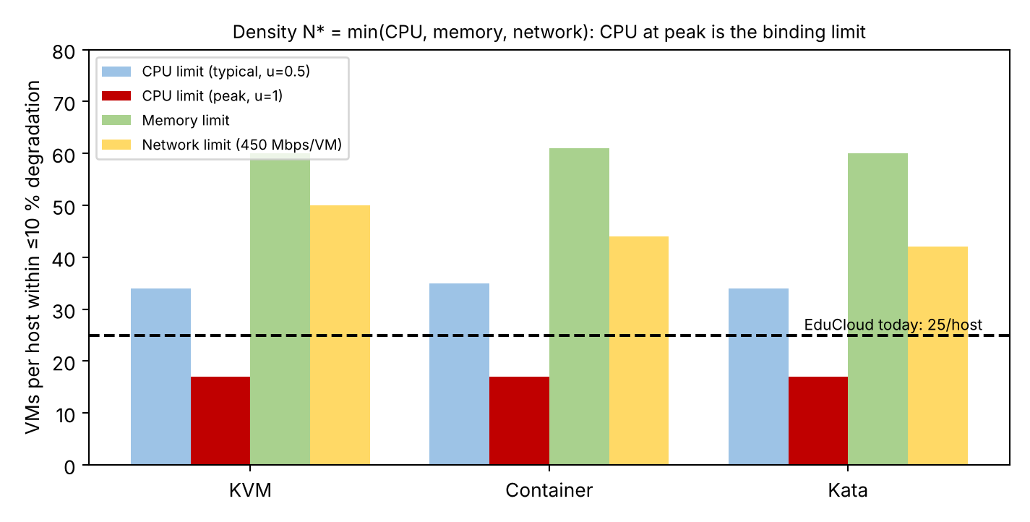
Figure 6: Density limits per host for each approach, derived in Section 3.4.
3.4 Density under a service-level target (≤ 10 % degradation)
Density is the smallest of the limits from CPU, memory and network. For the CPU, I find the largest overcommit r for which D = 1 − (1 − o)(1 − s) ≤ 0.10 and convert it to VMs: N_cpu = floor(r_max × 64 / v).
For KVM at peak (u = 1) we need (1 − s) ≥ 0.90/0.97 = 0.928, i.e. s ≤ 7.2 %. Solving 1 − 1/r + 0.005(r − 1) ≤ 0.072 gives r_max = 1.077, so N_cpu = floor(1.077 × 64 / 4) = 17 VMs per host. At typical load (u = 0.5), ρ = 0.5 r stays below 1 until r = 2, and r_max = 2.14, so N_cpu = 34 VMs. Containers give 35 and 17; Kata 34 and 17. For the network, with a peak demand of 450 mbps per VM (3× the normal 150 Mbps) and a 90 % utilisation limit, N_net = floor(0.9 × 25 / 0.45) = 50 for KVM, 44 for containers and 42 for Kata. Memory allows 60–61.
Result: N* = min(N_cpu, N_mem, N_net) = 17 VMs per host at peak and 34 at typical load, so CPU is the binding resource and EduCloud’s 25 VMs per host is above the limit at peak. The three approaches differ little in density; what separates them is isolation (Task 5) and I/O behaviour.
TASK 4: Performance Under Different Operating Conditions (4 Marks)
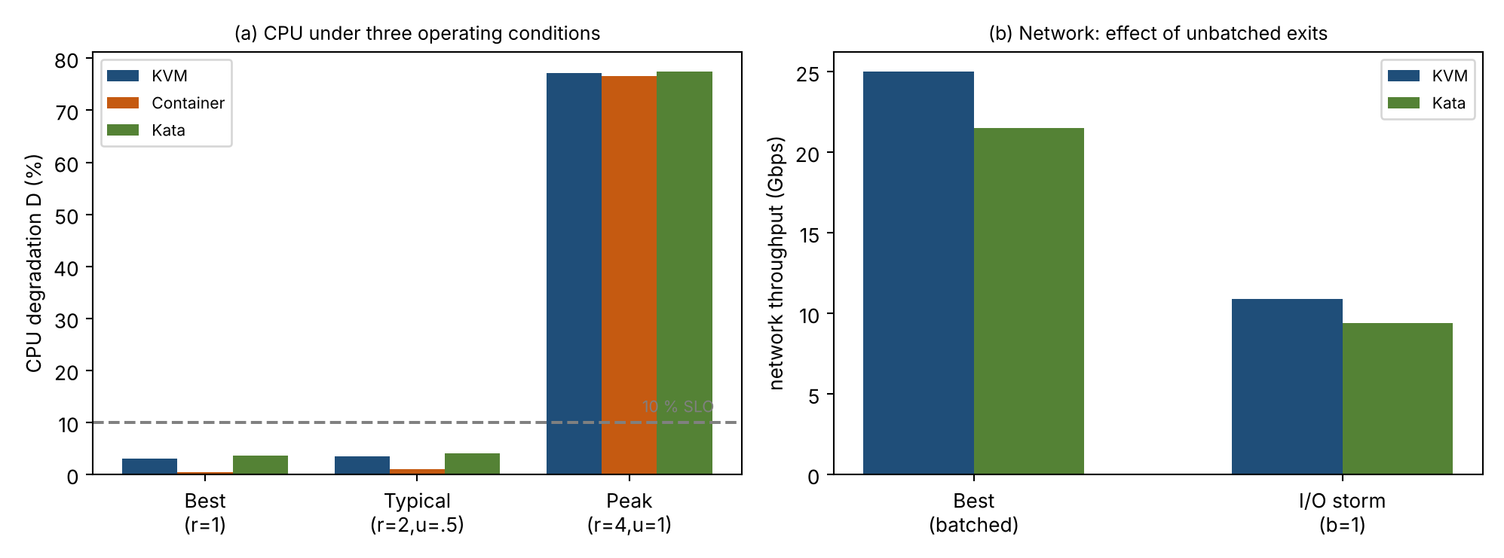
Figure 7: (a) CPU degradation in the best, typical and worst case; (b) network throughput when virtqueue batching is lost.
Best case
Conditions: vCPUs pinned one-to-one to cores (r = 1), CPU-bound or cache-resident work, huge pages (fewer TLB misses and cheaper nested page walks), batched virtio or SR-IOV I/O, and no co-located noisy tenants.
Inside the virtualization layer: guest instructions run natively, so the only cost is the exit overhead. Pinned vCPUs never leave their cores, so extended-page-table entries stay in the TLB, and with batching of 32 each packet causes 1/32 of an exit. The overhead is therefore at its minimum: 3.0 % for KVM, 0.5 % for containers (no exits, only 0.05 µs per system call) and 3.6 % for Kata. Throughput is at line rate for KVM (25 Gbps) and 22.4 and 21.5 Gbps for the bridged container and Kata; latency is the native latency plus a few microseconds.
Typical case (registration-week mixed web and database load)
Conditions: r ≈ 2:1 with each vCPU busy about half of the time (ρ ≈ 1).
Inside the virtualization layer: physical cores are just about fully used. A vCPU that becomes runnable occasionally waits for a core, which shows up as small steal time (κ(r − 1) = 0.5 %) and as extra context switches and cache/TLB pollution. The average cost is only 3.5 % (KVM), 1.0 % (container) and 4.1 % (Kata), so mean throughput is within 4 % of native. The visible effect is on tail latency: a request that arrives while its vCPU is descheduled waits for a scheduling quantum (a millisecond or more), so the 95th-percentile latency grows much more than the mean.
Worst cases
• Noisy-neighbour CPU interference (r = 4:1, u = 1). Demand is 4 cores per core, so the scheduler time-slices every vCPU and each receives only a quarter: C = 0.228 (KVM), i.e. D = 77 %. A response needing t seconds of CPU takes about t/(1 − s) ≈ 4.3 t. The overhead from virtualization itself is irrelevant; what matters is the share. A noisy neighbour also evicts cache lines and TLB entries, so the real result is slightly worse than the model. Containers are no better (76.6 %) because they share the same cores and, in addition, the same kernel locks and page cache.
• I/O storm. Latency is governed by queueing: for a device with service time S = 100 µs, mean latency is S/(1 − ρ). A victim alone at 20 % utilisation sees 0.125 ms; when a neighbour pushes the total to 90 % it sees 1 ms, and 3.3 ms at 97 % (Figure 8a). Without per-tenant limits a neighbour with queue depth 128 against the victim’s depth of 4 takes 97 % of the device (Figure 8b). If batching is also lost (b = 1), the per-packet cost of KVM becomes 0.6 + 1.5 + 0.15 = 2.25 µs, so two cores handle only 0.89 Mpps, 10.9 Gbps instead of 25 Gbps (a 56 % drop); Kata falls to about 9.4 Gbps. Containers are most exposed because they share the kernel’s block layer and softirq cores.
• Memory overcommit with swapping. Once the guests’ working sets exceed RAM, the guest is stalled on page faults of 100 µs instead of 100 ns. As shown in Task 3, a 0.1 % fault rate doubles access time and throughput drops by an order of magnitude as faults increase. Ballooning inside a VM can shift pressure to the guest’s cache, but host swapping is invisible to the guest and the worst for latency. A container hits its cgroup limit and is reclaimed or OOM-killed instead.
• Live migration during peak load. Pre-copy migration repeatedly copies dirty pages. Total time is T = (V/B_mig) / (1 − D/B_mig). With V = 8 GB and B_mig = 2.8 GB/s (about 22 Gbps): 4.4 s if the guest dirties 1 GB/s but 26.7 s at 2.5 GB/s, and migration will not converge if D approaches B_mig (Figure 9). During this time the migration stream occupies about 22 of the 25 Gbps, so SIS traffic on the same NIC queues behind it and its latency is multiplied by 1/(1 − ρ). Live migration of containers is not production-grade (CRIU checkpoint/restore), so containers are normally restarted elsewhere.
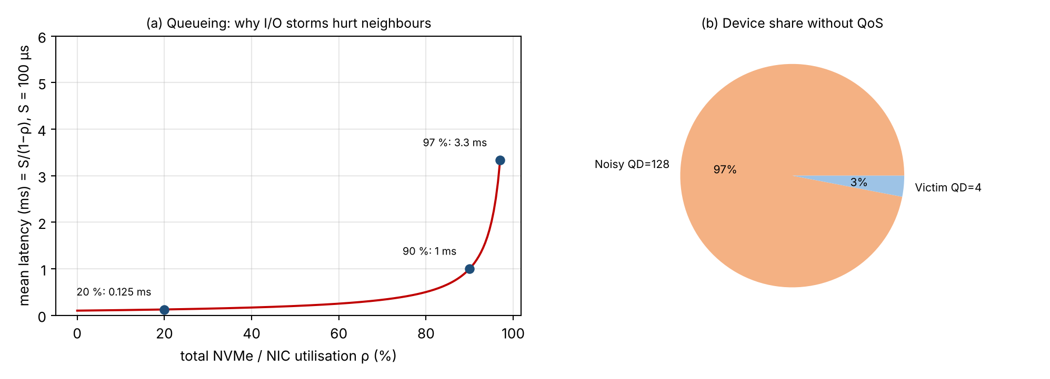
Figure 8: (a) Mean latency versus device utilisation; (b) device share of a victim and a noisy neighbour with no QoS.
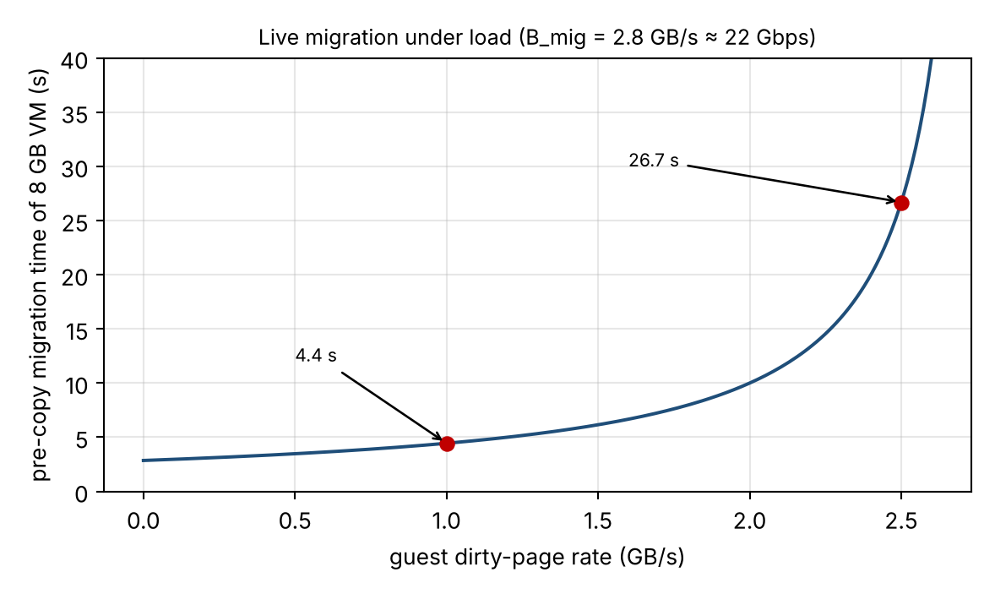
Figure 9: Pre-copy live-migration time versus the guest dirty-page rate.
TASK 5: Security Threat and Vulnerability Analysis (3 Marks)
Attack surface of each approach
KVM VM. The attack surface is KVM (a small kernel module), the QEMU device emulator (a large user-space program that emulates disks, NICs and USB; historically the largest source of escape bugs), the virtio back-ends, the management plane (libvirt/OpenStack API, SSH, consoles), the VM images and snapshots (qcow2 files that are copied between departments) and the virtual network (OVS/bridge, VXLAN). Each VM has its own guest kernel, which must be patched separately.
Container. The attack surface is the entire host Linux kernel as seen through about 350 system calls, plus runc/containerd, the Docker socket and Kubernetes API, the image registry and the flat bridge or overlay network. Because the kernel is shared, a single kernel bug exposes all tenants.
Kata micro-VM. The attack surface is smaller than containers’ because the tenant talks to its own guest kernel, and the host sees only the VMM and the virtio-fs daemon, plus the Kubernetes API and runtime, images and virtual network.
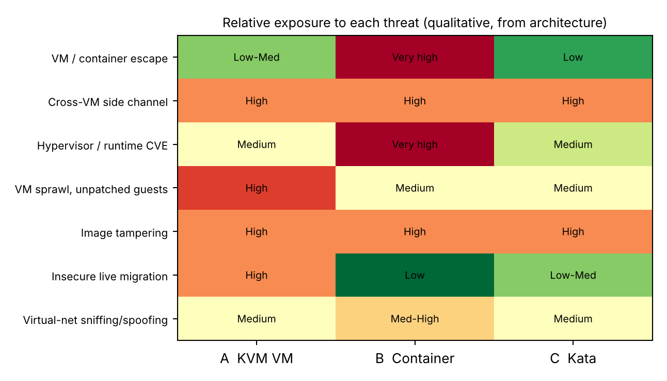
Figure 10: Relative exposure of each approach to the seven threat categories (green = low, red = high).
Threat categories and which approach is more or less exposed
• 1. VM / container escape. A container escape needs only a kernel or runc flaw, since the kernel is shared, so containers are the most exposed. An attacker in a VM must break KVM or the QEMU device model, which is harder; Kata adds a second layer (guest kernel then VMM), so it is the least exposed.
• 2. Cross-VM side-channel attacks (cache, SMT, Spectre/MDS). All three approaches share CPU caches and cores. The exposure is high in each, and what decides it is placement, not architecture. Mitigations such as disabling SMT or dedicated hosts address it.
• 3. Hypervisor / runtime vulnerabilities. More code reachable by the tenant means more exposure: containers (whole kernel and runc) are high, KVM medium (QEMU/KVM CVEs), Kata medium-low (smaller VMM and a disposable guest kernel).
• 4. VM sprawl and unpatched guests. The audit found outdated guest kernels. In KVM and Kata every guest has a kernel to patch, so sprawl is most dangerous in KVM (many long-lived VMs). Containers are easier to rebuild from patched images, but a host-kernel patch affects every container at once.
• 5. Image tampering and uncontrolled copying. The audit shows images copied freely between teams. This is equally severe for all approaches because it is a process failure: unsigned images can contain backdoors or old software.
• 6. Insecure live migration. The entire guest memory (database pages, keys, sessions) crosses the network in clear text if migration is not encrypted. KVM and Kata with migration are exposed; containers are rarely live-migrated, so are less exposed.
• 7. Virtual-network sniffing and spoofing. A flat bridge or shared VLAN lets a compromised tenant sniff or spoof traffic. This exists in all three; containers on a single bridge are slightly more exposed than VMs with separate virtual NICs and per-VM firewall rules.
Impact on student records (confidentiality, integrity, availability)
• Confidentiality. An escape or side-channel attack from a co-located departmental VM or container could read SIS database pages, session tokens and credentials; sniffed or unencrypted migration traffic leaks memory contents. This is the biggest risk for containers on shared hosts and SMT-on shared hosts.
• Integrity. Tampered images or an attacker with host control could modify grades or registrations; an unpatched guest kernel is an easy entry point.
• Availability. Noisy neighbours, a hypervisor crash, a kernel panic that takes down every container on a host, or a failed migration interrupt registration directly. This is exactly the failed-logins symptom EduCloud saw.
TASK 6: Formulate the Isolation–Performance Trade-off (3 Marks)
The formulation is built from the quantities derived in Task 3 (overhead o, steal s, density limits) and the threat ranking in Task 5. It is a small mixed-integer optimisation: choose where to run each workload and how to protect it, so that cost is minimised while performance and isolation requirements are met.
Decision variables
• x_{a,h} ∈ {0,1}: approach a (KVM, container, Kata) used on host h. n_{w,h} ≥ 0: number of instances of workload w (SIS, LMS, exam portal, research, external) on host h.
• z_{t,h} ∈ {0,1}: tenant class t is placed on host h (dedicated or shared hosts). y_h ∈ {0,1}: host h is used. s_h ∈ {0,1}: SMT on or off.
• q_j ∈ {0,1}: mitigation j is enabled (KPTI/L1D flush, memory encryption, image signing, micro-segmentation, encrypted migration).
Objective: minimise the combined cost
J = Σ_h c_h·y_h + α·Σ_w D_w + β·Σ_w I_w·R_w + γ·Σ_j κ_j·q_j
• c_h is the cost of host h (the infrastructure term, which is what dedicated hosts increase).
• D_w = 1 − (1 − o_a)(1 − s(r_h, u)) is the performance degradation of workload w from Task 3.
• R_w is residual risk: the sum over threats of p(a, threat) multiplied by Π_j (1 − e_{j,threat}·q_j), where p comes from the Task 5 exposure and e is the effectiveness of mitigation j. I_w is the impact weight (SIS = 10, LMS = 5, research = 1).
• κ_j is the operational cost of mitigation j, and α, β, γ are weights set by university policy.
Constraints
(1) Performance D_w ≤ 0.10 i.e. Σ_w n_{w,h}·v_w ≤ r_max(a,u)·P_h (Task 3: r_max = 1.077 at peak → 17 VMs)
(2) Memory Σ_w n_{w,h}(m_w + m_ovh,a) ≤ M − M_res (Task 3: 60 VMs)
(3) Network Σ_w n_{w,h}·d_w ≤ 0.9·T_host,a (Task 3: 50 VMs for KVM)
(4) Isolation a ∈ {KVM, Kata} for SIS; z_SIS,h + z_ext,h ≤ 1 on every host; s_h = 0 on SIS hosts
(5) Capacity Σ_h y_h ≤ H_available (16 hosts today)
(6) Integrity image signing q_sign = 1 for every workload that holds student records
How these combine. A plain container on shared hosts has the lowest cost and performance terms (density 35, D ≈ 0.5 %) but the highest risk term, because of the shared kernel and an impact weight of 10 for the SIS. Constraint (4) therefore removes it for the SIS. Disabling SMT reduces R (side channels) but raises the host-cost term because capacity falls by about 20 %. Dedicated hosts reduce R further at the cost of c_h. The optimum is a mix: VMs on dedicated SMT-off hosts for the SIS, and the denser container design for trusted LMS tiers. Figure 11 shows the trade-off: only configurations above the red isolation line are feasible for the SIS, and among them the dedicated KVM option gives up density (17 per host) to buy isolation.
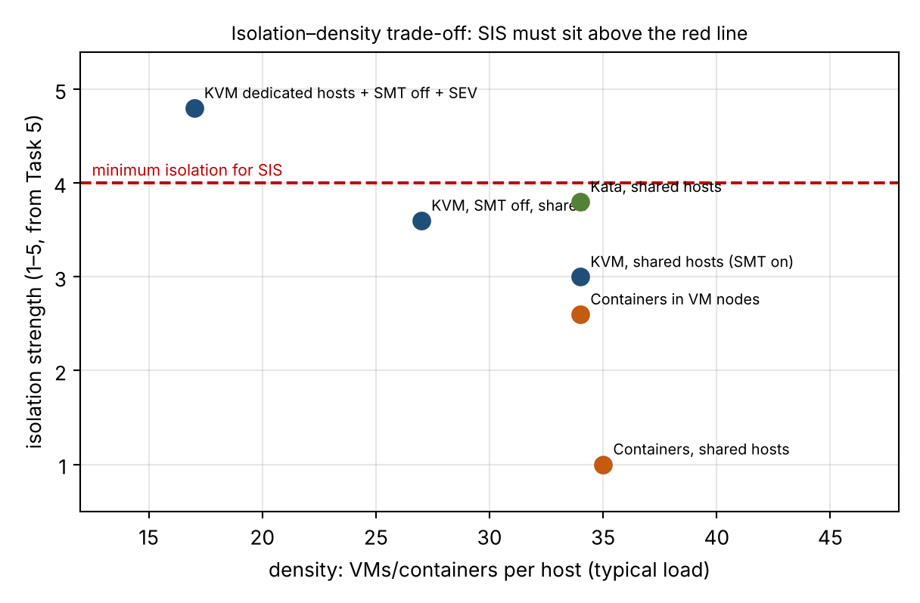
Figure 11: Isolation versus density for the candidate configurations (isolation score 1 to 5 from the Task 5 ranking).

TASK 7: Evaluate Mitigation Strategies (4 Marks)
I evaluate eight mitigations against the Task 5 threats. The cost of each is estimated with the Task 3 model (Figure 12 summarises them).
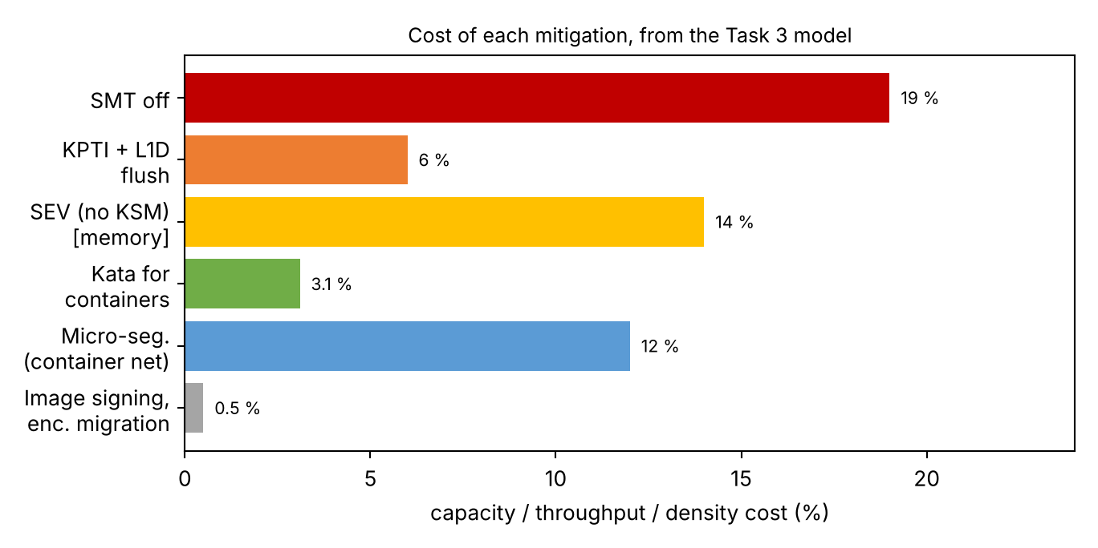
Figure 12: Cost of each mitigation estimated with the Task 3 model.
• 1. Disable SMT (threat 2, side channels). Applicable because sibling hyper-threads share caches and execution ports, which is the channel used by cross-VM attacks. Residual risk: last-level-cache and memory-bus channels between cores remain. Cost: if SMT adds about 25 % throughput, capacity falls from 80 to 64 core-equivalents, so peak CPU density falls from 21 to 17 VMs per host (−19 %). Acceptable for the SIS: yes, on SIS hosts only, because the SIS is limited by peak CPU headroom, which is fixed by adding hosts.
• 2. Kernel page-table isolation (KPTI) and L1D flush on VM entry (Meltdown/L1TF, threats 2–3). Applicable because it separates kernel and user mappings and flushes the L1 cache when a guest is entered, so speculative reads do not cross the boundary. Residual risk: new speculative-execution variants. Cost: a system call rises from 0.2 µs to about 0.35 µs (+0.15 µs × 100 000/s = 1.5 % CPU); if the flush raises an exit from 1.5 µs to 2.5 µs, o_KVM rises from 3 % to 5 %, so r_max at peak falls from 1.077 to 1.054 and density from 17 to 16 VMs. Acceptable: yes.
• 3. Dedicated hosts for the SIS (threats 1–3). Applicable because no untrusted co-tenant means no escape or side-channel path. Residual risk: a compromise inside SIS itself. Cost: for an assumed 60 SIS VMs, sharing hosts at typical density needs 60/34 ≈ 2 hosts, but dedicated hosts sized for peak need 60/17 = 4 hosts, so +2 hosts (12.5 % of the 16). Acceptable: yes, and it is also the simplest way to show the regulator that records are isolated.
• 4. Sandboxed runtime (Kata) for containers (threats 1 and 3). Applicable because it puts a hardware boundary and a separate guest kernel under each pod. Residual risk: VMM/QEMU bugs and side channels. Cost: CPU overhead rises from 0.5 % to 3.6 %, memory per pod rises by 0.18 GB (N_mem from 61 to 60), network falls from 22.4 to 21.5 Gbps, and start-up grows from about 0.1 s to about 0.5–1 s. Acceptable: yes, for external or unreviewed images; unnecessary for trusted LMS code.
• 5. Hardware memory encryption (AMD SEV-SNP or Intel TDX) (threats 2 and 6). Applicable because guest RAM is encrypted with a per-VM key, protecting against a malicious host, cold-boot and memory snooping. Residual risk: bugs inside the guest, availability attacks. Cost: about 3 % extra CPU (assumed) and the loss of KSM page sharing, so N_mem falls from 70 to 60 (−14 %). Acceptable: yes, since memory is not the bottleneck (25 VMs use only 39 % of RAM).
• 6. Image signing and a controlled registry (threat 5). Applicable because only images signed by IT can be deployed, ending free copying. Residual risk: a compromised build pipeline. Cost: no run-time cost; verifying a 20 GB image at 500 MB/s takes about 40 s once at deployment. Acceptable: yes.
• 7. Micro-segmentation (threat 7). Applicable because per-VM firewall rules in the virtual switch block lateral movement and spoofing. Residual risk: rule mistakes and a compromised permitted path. Cost: about +0.15 µs per packet: KVM goes from 0.797 µs to 0.947 µs, still 2.11 Mpps, which is above line rate (no loss); a bridged container goes from 1.10 to 1.25 µs, 1.6 Mpps = 19.7 Gbps (−12 %). Acceptable: yes.
• 8. Encrypted live migration (TLS/IPsec) (threat 6). Applicable because it protects guest memory in transit. Residual risk: compromise of an end host. Cost: about one core of AES-GCM for 2.8 GB/s and migration time about 10 % longer. Acceptable: yes.
Overall for the SIS: applying mitigations 1, 2, 3, 5, 6, 7 and 8 reduces peak CPU density from 21 to about 16 VMs per host (roughly a quarter), costs about two extra hosts, and removes the main threat paths. Because the SIS requires only about 60 VMs and the issue is peak CPU headroom, this trade-off is acceptable and cheaper than a breach of student records.
TASK 8: Implement and Test (4 Marks)
Test environment
Use one Linux host (Ubuntu 22.04/24.04) with Intel VT-x or AMD-V enabled in the BIOS, plus qemu-kvm, libvirt, docker.io, kata-containers, sysbench, fio, iperf3 and stress-ng. If the host is a laptop that is itself a VM, enable nested virtualization (modprobe kvm_intel nested=1) and document this as a limitation, because nested virtualization makes VM exits more expensive and raises measured overhead above the model. If the laptop has fewer cores than N, reduce the maximum N proportionally and state it.
Use identical resources for every approach: 1 vCPU (--cpus=1 for containers), 2 GB RAM and 10 GB disk per instance; instance counts N = 1, 2, 4, 8, 16; five repetitions of every test; report mean ± standard deviation. The lab host has P cores and v = 1, u = 1 for the CPU-bound test, so r = N/P and the Task 3 equations apply directly with the lab’s core count.
Starting the instances
# A: KVM VM (virtio disk and vhost-net NIC)
qemu-system-x86_64 -enable-kvm -cpu host -smp 1 -m 2G -drive file=vm$i.qcow2,if=virtio \
-netdev tap,id=n0,vhost=on -device virtio-net-pci,netdev=n0 -nographic
# B: container
docker run -d --name c$i --cpus=1 --memory=2g ubuntu:22.04 sleep infinity
# C: Kata micro-VM
docker run -d --runtime=io.containerd.kata.v2 --name k$i --cpus=1 --memory=2g ubuntu:22.04 sleep infinity
Workloads (run identically on bare metal and in each instance)
sysbench cpu --threads=1 --time=30 run # CPU-bound: events per second
sysbench memory --memory-block-size=1M --memory-total-size=20G run # memory-intensive
fio --name=r --rw=randread --bs=4k --iodepth=32 --size=2G --runtime=30 --time_based --direct=1 --output-format=json
iperf3 -c <server> -t 30 -P 4 -J # network, server on another host
/usr/bin/time -v <start command> # start-up time and memory footprint
perf stat -e context-switches,cpu-migrations -a sleep 30 # context switches
grep steal /proc/stat ; perf kvm stat live # steal time and VM exits
Interference test (noisy neighbour)
Start a neighbour on the same cores and storage as the victim: stress-ng --cpu 4 --vm 2 --vm-bytes 80% and fio --rw=randwrite --iodepth=128. While it runs, measure the victim’s sysbench result and its 4 KB fio read latency (mean and p95, iodepth 4). Repeat with a limit on the neighbour (cgroup io.max for containers, virtio-blk throttling for VMs) to see how much isolation a limit gives.
Security validation
• Namespace/cgroup isolation: lsns, cat /proc/self/cgroup and docker run --rm alpine ps (the container sees only its own processes).
• Kernel sharing: uname -r inside a container shows the host’s kernel version, while inside the KVM VM and the Kata pod it shows the guest’s own kernel. This demonstrates the trust-boundary difference of Figure 1.
• Mitigation status: grep . /sys/devices/system/cpu/vulnerabilities/* and cat /sys/devices/system/cpu/smt/active. Repeat the performance tests after echo off > /sys/devices/system/cpu/smt/control and with mitigations=off versus the default boot option to obtain results with and without a mitigation.
• Seccomp/capabilities: docker run --rm alpine unshare -r is blocked by the default profile but succeeds with --privileged, showing that the isolation depends on configuration.
Take screenshots of the commands and their output for the evidence chain on the mark sheet (architecture diagrams, scripts, experiments, noisy-neighbour test, security validation, tables/graphs).
TASK 9: Record Experimental Performance (3 Marks)
The table and graphs below are the model-predicted curves for a lab host with P = 8 cores, v = 1 vCPU per instance and u = 1, and a 25 Gbps NIC. The “Measured” column is blank on purpose: replace it with your own mean ± SD of at least five repetitions and plot your points over the curves. Also record CPU steal, context switches, VM exits, start-up time and memory per instance as listed in Task 8.
Metric | N | Predicted (model) | Measured mean ± SD | Degradation vs bare metal
CPU throughput per instance – KVM | 1–8 / 16 | 97.0 % / 48.0 % of bare metal
CPU throughput per instance – Container | 1–8 / 16 | 99.5 % / 49.3 %
CPU throughput per instance – Kata | 1–8 / 16 | 96.4 % / 47.7 %
iperf3 per instance – KVM / Container / Kata | 4 | 6.25 / 5.59 / 5.37 Gbps
iperf3 per instance – KVM / Container / Kata | 16 | 1.56 / 1.40 / 1.34 Gbps
Victim 4K read p95, no QoS, neighbour 60 % | — | 1.5 ms
Victim 4K read p95, neighbour capped at 30 % | — | 0.6 ms
Memory footprint per idle instance | 1 | Container 20 MB; Kata 200 MB; KVM 250 MB
Start-up time | 1 | Expected order: container ≪ Kata < KVM
With vs without SMT-off and KPTI | — | Density −19 %, exit cost +1 µs

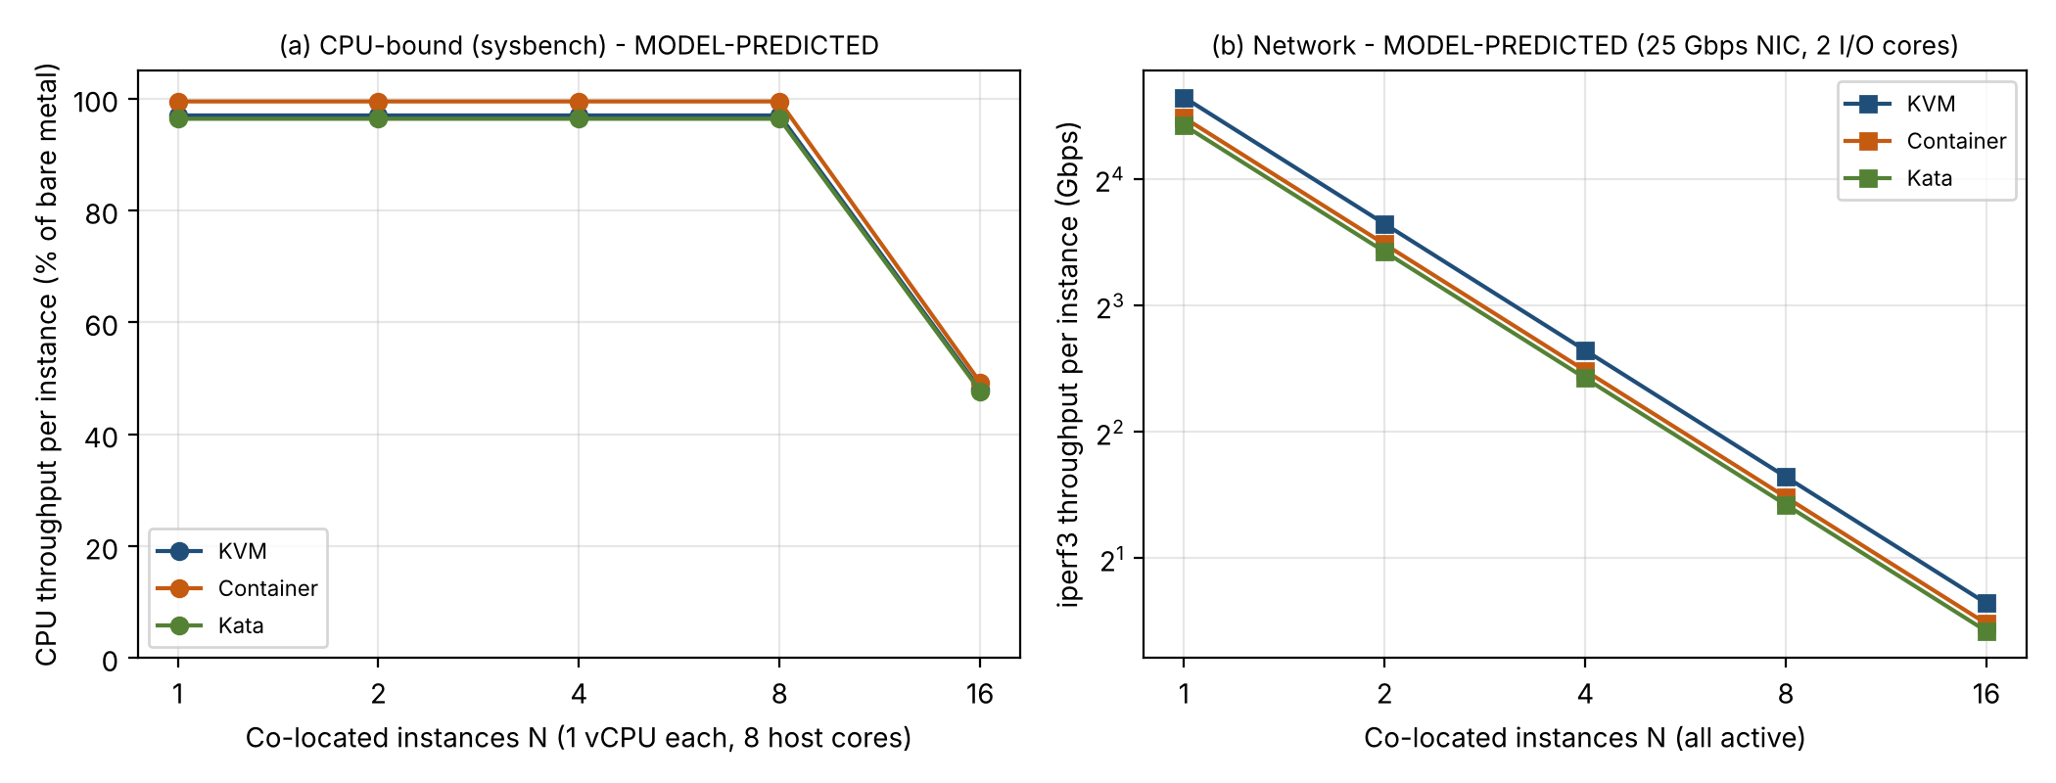
Graph 1: Throughput versus number of co-located instances (model prediction): (a) CPU, (b) network. Overlay measured points with error bars.
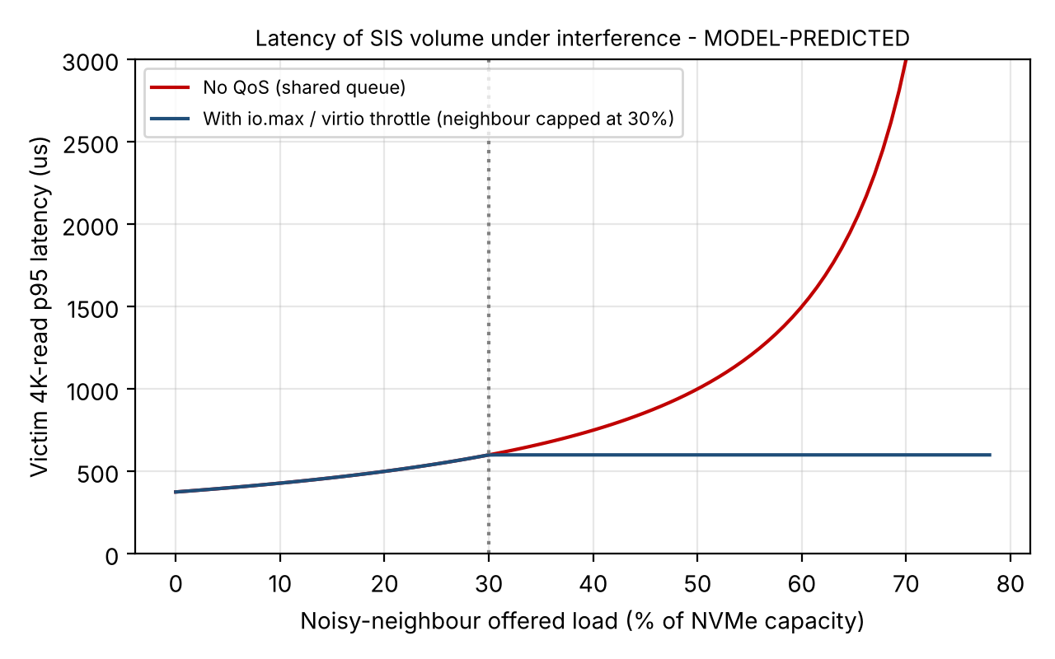
Graph 2: Victim latency under interference (model prediction, M/M/1 with S = 100 µs and a victim load of 20 %). The capped curve shows the benefit of a rate limit.
TASK 10: Compare Theory with Experiment (4 Marks)
For each measurement, compute the error as (Measured − Predicted) / Predicted × 100 %. I treat |error| ≤ 15 % as agreement for throughput and ≤ 30 % for p95 latency, since the model ignores caches and the exact scheduler. The interpretation below is what the model predicts you should see and how to explain deviations; confirm it against your own numbers.
Do the trends agree with the model?
The model predicts per-instance CPU throughput that stays flat while N·v ≤ P (only the overhead o, at 97 % for KVM, 99.5 % for containers and 96.4 % for Kata) and then falls in proportion to 1/r when N exceeds the core count (about 50 % at r = 2). Network throughput per instance should fall as 1/N for all approaches. If your CPU curve bends near N = P and your iperf3 curve halves each time N doubles, the steal-time and fair-share equations are validated.
Which approach scales better?
Containers are predicted to scale best for CPU and disk: they have no exit tax (o = 0.5 %) and the smallest per-instance footprint, so they reach the highest density. KVM follows closely (CPU density is the same at peak because the SLO is driven by overcommit). On the network, KVM with vhost-net should equal or exceed a bridged container, because the bridge/NAT path adds 0.5 µs per packet; if the container matches KVM when you use host networking, the model’s attribution of the container overhead to the virtual switch is confirmed. Kata is expected to be slowest on I/O and start-up because of the extra guest kernel and virtio-fs hop.
Why predictions and measurements differ
• Nested virtualization on a laptop makes each VM exit far more expensive than 1.5 µs, so measured KVM and Kata overhead will exceed the prediction.
• CPU frequency scaling and thermal throttling lower absolute throughput for every approach, especially at high N.
• Scheduler behaviour: CFS and the KVM scheduler are not an ideal fair-share system, and cache and TLB pollution add to the contention term κ.
• Unmodelled I/O paths: qcow2 metadata, overlayfs copy-up and virtio-fs add latency not in the model, so fio will usually fall below the prediction for VMs and Kata.
• Fewer cores than in production: with a small laptop, r exceeds 1 at a much smaller N, so the knee appears earlier than on a 64-core host.
Does any measurement change the security conclusions?
The container’s uname -r equals the host kernel, and a noisy container will interfere with the victim through the shared kernel; both confirm the Task 5 ranking that containers have the weakest isolation. If the cost of SMT-off and KPTI is higher than predicted (more than 19 % and 2 %), the conclusion that the SIS needs strong isolation does not change, but the number of dedicated hosts must be increased. If an unthrottled neighbour degrades the victim much more than a throttled one, it confirms that rate limits are required in addition to host separation.
TASK 11: Recommend and Defend the Final Architecture (4 Marks)
Recommendation: a tiered hybrid
• SIS (student records and databases) → KVM virtual machines on dedicated hosts with SMT off, KPTI/L1D mitigations, hardware memory encryption where available, signed images, encrypted migration and micro-segmentation.
• LMS web/application tiers and the examination portal → containers running inside KVM node VMs, one set of node VMs per department/trust domain. This gives container density and very fast scale-out in registration week, while the VM is the isolation boundary between departments; no container kernel is shared across trust domains.
• Untrusted or externally supplied images → Kata micro-VMs.
Why this is better than the alternatives
Pure containers on shared hosts give the highest density (35 against 34 VMs per host at typical load) but the shared kernel puts student records in the same trust domain as any co-tenant, and Task 5 and Task 6 rule this out for the SIS. Pure VMs everywhere are secure, but they cost 3 % CPU and 250 MB per instance, with slower start-up and less elasticity for the LMS; the model shows that the CPU limit at peak (17 VMs per host) is the same for all three approaches, so changing hypervisors would not solve the registration-week slowdown. Kata everywhere adds 3.1 % CPU, about 4 % lower network throughput and slower start-up for trusted LMS code with little security benefit. The hybrid places the strong boundary where the data is and the dense boundary where the risk is low.
Performance, security, operations and limits
• Modelled performance: 3.5 % degradation at typical load; ≤ 10 % up to an overcommit of 2.1:1 typical or 1.08:1 at peak. The model shows that EduCloud today (1.56:1) exceeds the target at peak (38 % degradation), so the recommendation includes right-sizing vCPUs and adding capacity. Insert your measured values from Task 9 in this paragraph when you finalise it.
• Security posture and residual risk: hardware isolation, dedicated hosts and encryption for the SIS. Residual risks are vulnerabilities in KVM/QEMU, microarchitectural channels not covered by SMT-off, and insider misuse.
• Operational costs: patch hosts by live-migrating VMs (encrypted, on a dedicated NIC); keep a signed golden-image registry and rebuild images automatically so no outdated guest kernels remain; monitor steal time (alert above 5 %), p95 I/O latency and exit rates; manage Kubernetes on top of the VMs.
• Limitations and trade-offs: about two extra hosts for dedicated SIS capacity, loss of KSM page sharing with memory encryption, and one more layer (Kubernetes inside VMs) to operate.
• Growth from 400 to several thousand instances: with 17–35 instances per host, 4 000 instances need about 120–240 hosts, so the platform must be managed through automation (orchestration, image pipeline, host pools). The design scales because density grows through containers on VM nodes without a new kernel per service, and because isolation is controlled by policy (pools, signing, segmentation) rather than manual work.
TASK 12: Day-4 Design Challenge – Re-evaluate and Adapt the Design (8 Marks)
Impact Analysis (2 Marks)
What has changed. External collaborators will run Spark/Hadoop clusters on the same infrastructure as the SIS. The jobs run for hours and are I/O- and network-intensive, the registration peak is three times normal, hosts are patched by live migration, and a regulation now requires demonstrable isolation of student records from external tenants.
Assumptions that no longer hold. (1) Trusted tenants: external users run arbitrary code and must be treated as potentially hostile. (2) Workload mix: long batch jobs are mixed with short latency-sensitive SIS requests. (3) I/O profile: Spark shuffles and HDFS scans are sustained disk and network streams rather than short bursts. (4) Peak: 3× normal load.
Effect on performance. A shuffle can use about 20 Gbps of a 25 Gbps NIC (ρ = 0.8). Queueing multiplies the delay of other traffic on that NIC by 1/(1 − ρ): ×5 at 0.8 and ×20 at 0.95. A Spark scan at high queue depth can take 97 % of the NVMe queue (Figure 8). Executors keep cores busy for hours, so r·u stays above 1 on shared hosts. With triple load, the present 25 VMs per host move from D = 3.3 % at normal load to D = 38 % at peak, which is already above the 10 % target before any external workload is added.
Effect on the threat model. The adversary is now an external tenant with code execution next to student data. Escape, side-channel and network-sniffing threats become realistic rather than theoretical, and live migration moves host memory (which may hold SIS data) across the network, so it has to be encrypted and kept off shared paths. Because the regulator requires demonstrable isolation, “same host, different VM” is no longer a convincing argument.
Evaluation of the Original Design (2 Marks)
Performance. The Task 11 hybrid keeps degradation within 10 % only up to 17 VMs per host at peak. If the SIS, LMS and examination portal are about 250 VMs of 4 vCPUs (an assumption), they need 1000 / (64 × 1.077) = 14.5, i.e. 15 hosts at peak, which leaves only one of the 16 hosts for Spark. External workloads cannot be added to the shared pool without breaking the target.
Isolation. If external Spark VMs shared hosts with the SIS, VM isolation and SMT-off would reduce but not remove shared-hardware channels, and it would be hard to prove separation to a regulator. Containers for external tenants would be unacceptable because of the shared kernel.
Could another architecture do better overall? Kata for everything gives strong isolation but adds virtio-fs and extra network hops, which hurt I/O-heavy Spark. Bare-metal or SR-IOV VMs give the best Spark throughput but are heavy for small services. No single approach is best for both workloads, so a pool-based hybrid is better than any single architecture.
Adaptation or Redesign (2 Marks): decision = MODIFY
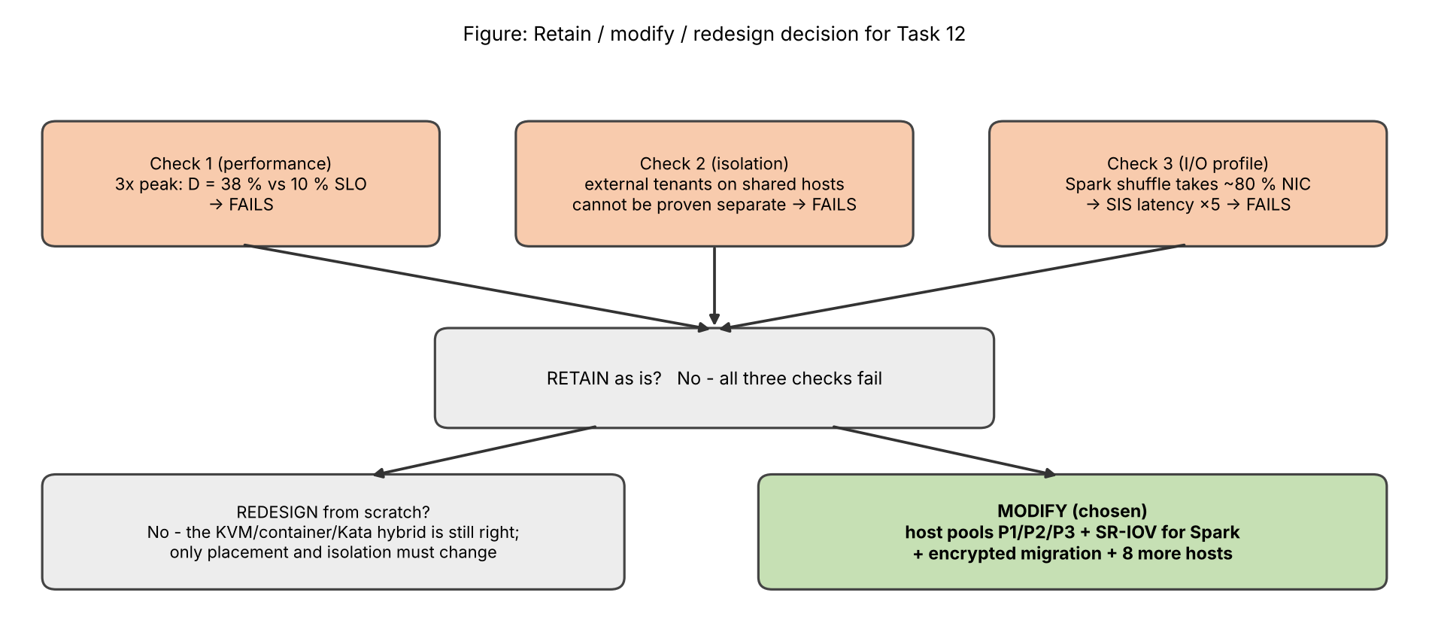
Figure 13: Decision between retain, modify and redesign.
The original design fails on performance (peak), isolation (external tenants) and I/O profile (Spark shuffles), so it cannot be retained. A full redesign is not needed, since the KVM/container/Kata hybrid is still the right toolbox; what must change is placement and isolation. I therefore modify the design by separating workloads into three host pools (Figure 14).
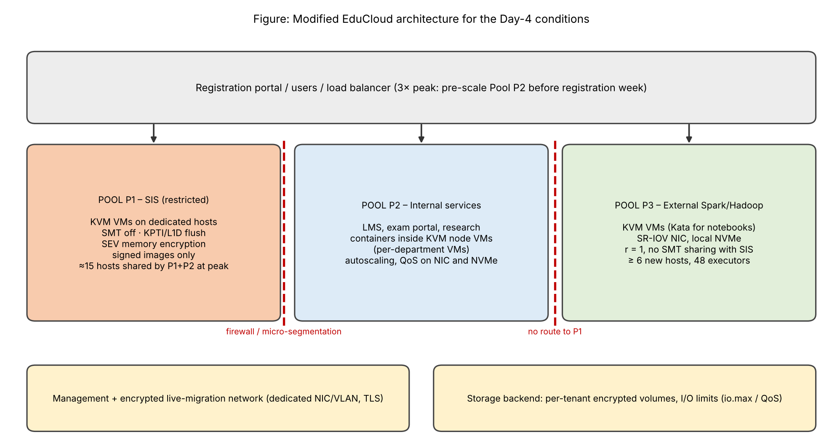
Figure 14: Modified EduCloud architecture with separate pools for SIS, internal services and external big-data workloads.
• Pool P1 – SIS (restricted): KVM VMs on dedicated hosts, SMT off, KPTI/L1D flush, SEV memory encryption, signed images only, migration only within the pool.
• Pool P2 – Internal services: LMS, exam portal and research as containers inside per-department KVM node VMs, with autoscaling and QoS limits on the NIC and NVMe; pre-scaled before registration week.
• Pool P3 – External big data: KVM VMs (Kata for interactive notebooks) with SR-IOV NICs and local NVMe, running at r = 1 and on hosts that never carry SIS VMs, on a separate VLAN with no route to P1. Six new hosts, with 8 executors of 8 vCPUs each, give 48 executors and ≈150 Gbps of aggregate network capacity.
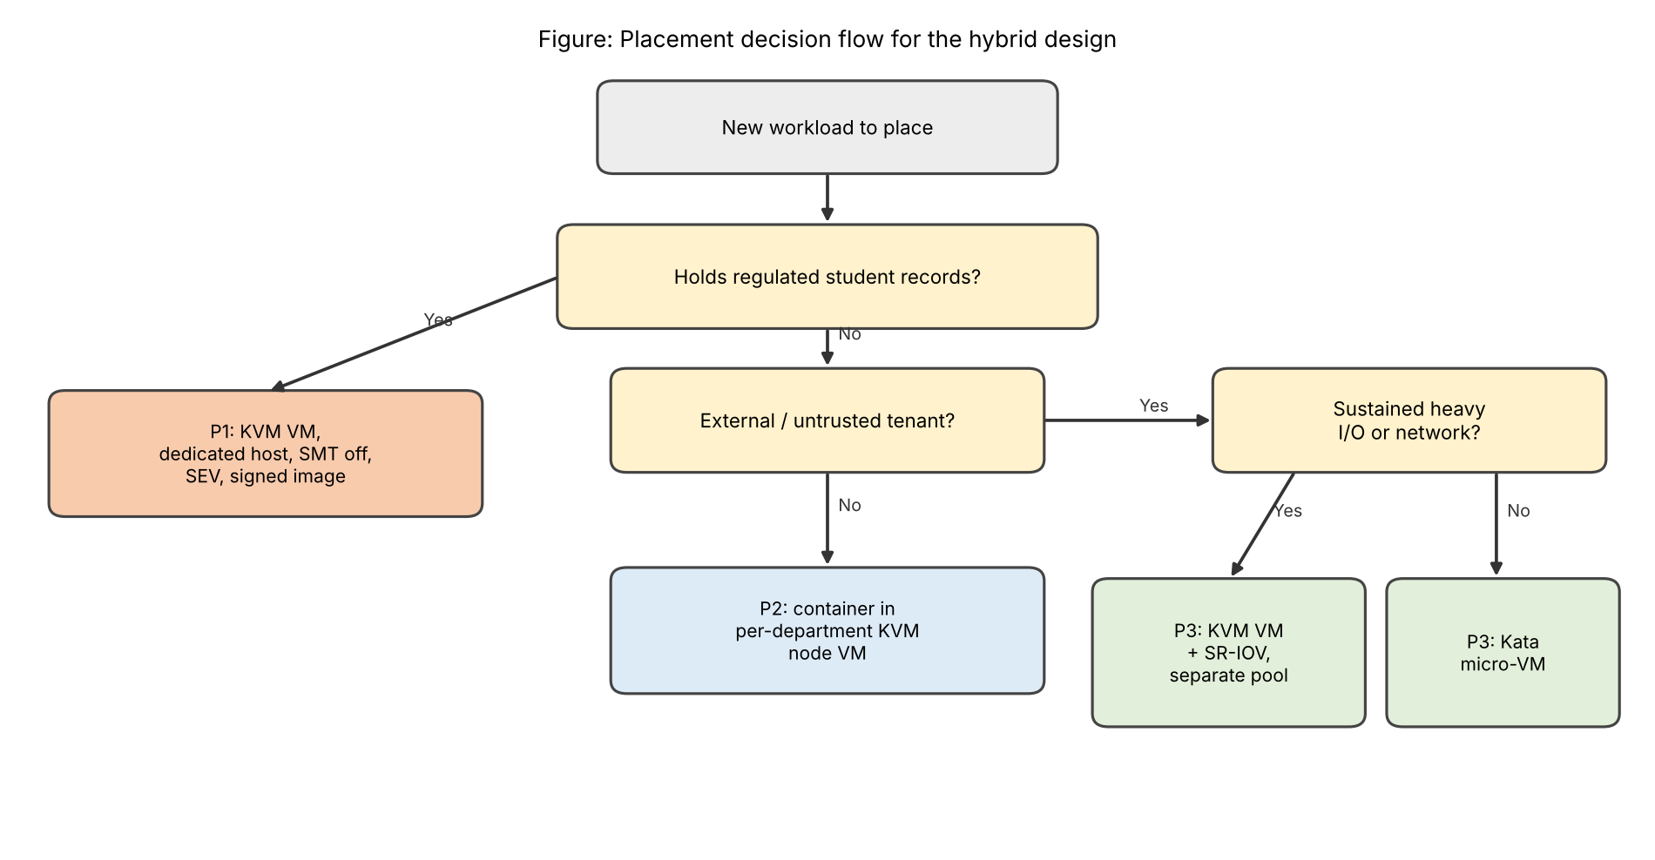
Figure 15: Flow used to decide which pool a new workload goes to.
Effect on density. SMT-off reduces peak CPU density on P1 from 21 to 17 VMs per host (−19 %). P3 runs without overcommit, so its density is low, but SR-IOV removes the exit tax (per-packet cost 0.65 µs instead of 0.8–1.15 µs) and gives line rate. The total extra capacity is about 2 hosts for the SIS and 6 for Spark.
Effect on throughput. Spark traffic runs on its own 25 Gbps NICs, so the SIS NIC load stays at its original level and its latency is unchanged, while Spark gets almost native network and disk speed.
Effect on attack surface. External tenants share no kernel, no host and no layer-2 network with student records. The remaining attack surface towards the SIS is the management plane and storage backend, protected by authentication, encrypted volumes and per-tenant I/O limits.
Live migration. Migration is encrypted (TLS), runs on a dedicated NIC/VLAN with auto-converge, and never crosses pools. At a dirty rate of 1 GB/s an 8 GB VM migrates in 4.4 s (Figure 9), and since it no longer shares a NIC with application traffic it does not hurt latency. For the 3× peak: pre-scale P2, right-size vCPUs, defer patching to off-peak and alert on steal time above 5 % and on p95 latency.
Evidence-Based Defence (2 Marks)
• Model: at peak, r_max = 1.077 allows only 17 VMs per host; with triple load the present 25 per host reach D = 38 %. Capacity, right-sizing and separate pools bring this back under 10 %.
• Noisy-neighbour experiment (Task 8/9): the model shows a victim volume rising from 0.375 ms p95 (alone) to 1.5 ms with a 60 % neighbour and 15 ms at 78 %, but staying at 0.6 ms when the neighbour is capped at 30 %. Limits clearly help, but a multi-hour Spark job still consumes the margin of a shared device, which justifies separate hosts and NICs for the external pool. Confirm the shape of this result with your own measurement.
• Mitigation experiment: SMT-off plus KPTI cost about 19–24 % of peak density (21 → 16–17 VMs per host); this is acceptable for the SIS and is what gives the isolation the regulator demands.
• Changed workload and tenancy: the new conditions make three original assumptions false (trusted tenants, I/O profile, peak), so “retain” cannot be defended; and since the hybrid toolbox is still valid, “redesign” would waste effort.
• Cost/density trade-off: about 8 additional hosts (2 for SIS isolation and 6 for external Spark) against an unacceptable regulatory and availability risk. The decision follows directly from the analysis: modify – keep the KVM + container + Kata hybrid, add dedicated SIS hosts, place external workloads in an SR-IOV VM pool, and encrypt migration.
Check before you submit
(1) Replace the predicted values in Tasks 9–10 with your own measured mean ± SD and graphs. (2) Check that the assumptions listed at the start match your lab hardware. (3) Fill in your name, register number and dates on page 1 and complete the mark sheet and checklists as your faculty requires.

